**Augmented Reality (AR) and Virtual Reality (VR) in Education**

Md. Foysal Ahmed

*Dept. of CSE*

*Daffodil International University*

*Dhaka, Bangladesh*

*foysal15-12486@diu.edu.bd*

***Abstract—***

***Keywords— Augmented reality, virtual reality, immersion, education.***

**I.** INTRODUCTION

Humans are 3D creatures. Our brain is the most powerful 3D computer in the world. We have evolved to think and store in three dimensions. When we view information on a flat sheet of paper or computer screen, our brain needs some time to convert the information into 3D so that we can use it. The fact that we can access 3D computers in our heads is the greatest promise of AR/VR to mankind. In recent years, technology has improved significantly. At present augmented reality and virtual reality are tied in the same thread. They are no longer compared in a different way hence they are not new technologies anymore. New learning tools are coming from these technologies due to which the education sector is becoming more strong and effective. Although AR and VR are well-known technologies in the mobile and game industry, their contribution to the education sector is now more visible.

It is important to have a general idea about AR and VR before understanding its key advances in the education sector. Starting with virtual reality, which takes us into a completely different world, which is the virtual world that is the full concept of this technology. With this kind of computer technology, a simulated environment can be created in which we can be a part of this experience. The experience of living in a virtual world can be visual, auditory and sometimes it gives haptic [3]. Virtual Reality is based on three basic concepts such as immersion, interaction and the connection of the user to the virtual environment [2]. “Sensorama” was a machine that was one of the first examples of immersive multi-sensor technology that could somehow be viewed as virtual reality [2]. In the immersive VR method, one can use 3D glass to experience the projected world and move freely which is the concept of “CAVE” environment [2]. In contrast to the virtual reality, which guides us in the complete immersion of the artificial world [3], the augmented reality adds information to the real world that we see and feel. In contrast to the virtual reality, which guides us in the complete immersion of the artificial world [3], the augmented reality adds information to the real world that we see and feel. It doesn't cut off the real world, but it is the enhancement of the real world where we mix the real world with the virtual object and therefore it is sometimes considered as mixed reality. If the real environment of a person is supplemented or expanded by computer-generated virtual objects or images, this can be referred to as augmented reality. Most of the mobile applications currently using AR technology have shown us new educational possibilities and various implementations in this field [4]. On the other hand, the value of using virtual reality in education will reduce our cognitive effort while minimizing explanations, and learners will feel more, leading to direct understanding [3]. The learning experience is an important part of any education system, so if we can integrate scenes, sounds, touch and emotions, it will make more sense. This is why educators are trying to implement these AR/VR technologies in the classroom to improve learning experience which will gradually improve student performance [10].

This research paper gives a brief glimpse into how AR and VR technologies can improve the learning process and also examines the potential of these technologies in education. In this research paper, we will also briefly review ongoing research and emerging AR/VR products that have educational value and the potential to improve the education system. It also illustrates the opportunities and challenges of implementing these technologies in this sector.

Augmented and virtual reality technology have paved the way for the renewal of our conventional education system in the twenty-first century [3]. Immersed VR / AR technologies have significant potential to transform learning and create an exciting adventure for Student [7]. At the end of this research, we can see that AR/VR can improve teaching methods for teachers and students at all levels, from elementary school to graduate education and all content areas [5]. In the near future, it can be predicted that AR and VR will be reliable enough to bring about positive changes in the teaching and learning methods that satisfy 21st century learners.

**II.** SEVERAL RESEARCH METHODOLOGY

Although AR and VR are considered in the same thread but still they are different in several areas. Figure 1 which is presented by Milgram et al. [11] where he shown the virtual and real environment as two boundary of a spectrum. The spectrum between real and virtual environment was called Reality. Virtuality (RV) [11] continuum and variety of AR and VR can be assign to this spectrum [12].

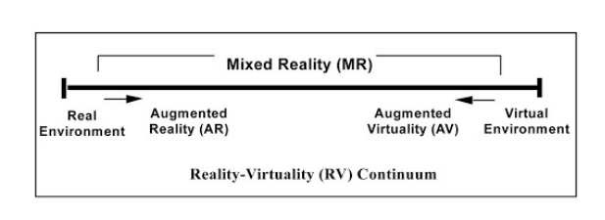

Fig: 1 A representation of a Reality-Virtuality (RV) Continuum [11]

Figure 2 which also shows more exact classification of AR and VR as shifting from Left to right the degree of reality decreases but most AR/VR products don’t necessarily use this term [1].

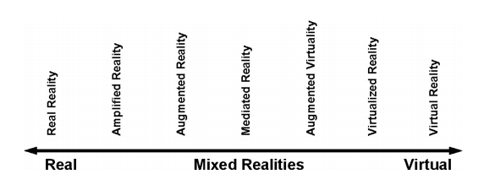

Fig: 2 A different classification ranging from the real environment to the virtual environment [12]

Therefore, a more traditional structure is needed to summarize this term. According to the research [1] in which Figure 3 was suggested for a more general representation of the classification of AR and VR.

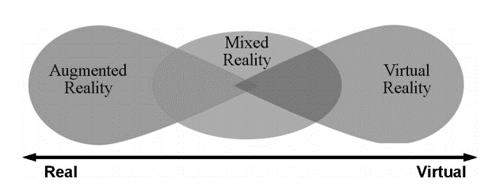

Fig: 3 A conventional diagram for AR and VR classification [1]

In this part of the research, we will try to show some AR/VR tools and equipment, as well as some ways to use these tools in education. In addition, we will see some of the methods and systems proposed by many researchers in their work. Finally, this section can embrace variety of outstanding works done by several researchers within the field of education.

1. *AR/VR Tools*

Applying AR / VR tools in education may be the best approach discussed in this research work. AR/VR technology is needed to combine real information with virtual or computer-generated environmental objects to experience an immersive AR/VR experience. But to enjoy this desired experience and have a perfect sense of AR / VR content, it is necessary to have AR / VR tools or gadgets. These tools can be visual, auditory, haptic, sense modality devices, and external devices equivalent to positioning systems [1]. Perception in virtual reality often takes place with a head-mounted display (HMD), with a rear-projected stereo projection screen/display around it, or a desktop screen. At present, there are many manufacturers who have already made low cost HMD devices. According to [1], Google Cardboard is the lowest cost HMD developed by google. The ​smartphone is placed on the back of the lens to show the content to the audience. Google Cardboard is also associated with the Software Development Kit (SDK), which provides a design platform to easily create virtual reality content for Android and iOS operating systems, which can be used to create educational content for mobile learning. In addition to Google, there is also the HTC Vive Pro for virtual reality, which can achieve interactive immersive experience in a simulated 3D environment [14].

HMD's which was developed for AR applications are quite different from VR. AR HMDs are very similar to eye-glasses with components like camera, IMU, microphone. AR glasses overlay virtual information or object onto the real world [15]. The computer-generated components appear on top of the glass while the user can see the actual environment through the glasses. However, AR HMDs are quite expensive although they can be applied in our classroom by focusing on the presentation of 3D models and other interactive objects [1]. Companies such as Google, Facebook, HTC and Sony (developed tools such as Cardboard, Oculus Rift, HTC Vive and the PlayStation VR helmet) have given this technology a new breath this time with real promises of success. They are working on big projects to advance this technology and enable its use in various fields, including education [3].

|  |  |  |  |  |  |  |
| --- | --- | --- | --- | --- | --- | --- |
| Name | AR/VR | Price ($) | Type | Position Tracking | Software | Sensors |
| Oculus Rift | VR | 399 | Tethered | Yes | Oculus | Accelerometer, gyroscope, magnetometer |
| PlayStation VR | VR | 300 | Tethered | Yes | Console | Accelerometer, gyroscope |
| HTC vive | VR | 650 | Tethered | Yes | SteamVR | Accelerometer, gyroscope, structured light |
| Samsung Gear VR | VR | 93 | Mobile | No | Android | Accelerometer, gyroscope, proximity sensor |
| Microsoft HoloLens | AR | >3000 | Tethered | - | Windows mixed reality | IMU, cameras, light ambient sensor, auditory system |
| Vuzix Blade | AR | >1000 | Tethered | - | Android | Head motion tracking sensors, cameras |
| Epson Moverio BT-300 | AR | 700 | Tethered | - | Android | GPS, geomagnetic, accelerometer, gyroscope |

Fig:4 Several AR /VR HMD devices from different manufactures [1]

1. *CAVE Environment*

CAVE takes place in an immersive virtual reality environment. In a room, the projection screen can be connected to the walls, ceiling and the floor. Users often use input devices such as joysticks or gloves to interact with virtual objects on the screen. For education, since multiple students can experience virtual reality at the same time, in the case of HMD, this can reduce (non-personal) school costs and help teachers guide all students during the test [1].

1. *Recent work by researchers*

A design strategy proposed by Dede [16] to combine virtual reality with the Immersed Multi-User Virtual Environment (MUVE) at Harvard University so that high school students can learn ecology. The name of the environment given as EcoMUVE. EcoMOV Pond's intermediate curriculum highlights the potential of immersive authentic simulations to teach ecological science concepts, scientific investigation (collaborative and individual), and complex functions.

A study on [15] described an augmented reality collaborative application (ARCA), which opened the door to collaborative learning using AR technology. ARCA enables remote location students to place their own live digital images directly in a real physical environment (local environment). For example, if the local environment includes a physical table with four chairs, occupied by two people, and two empty seats, the idea would be to place the digital (virtual) versions of remote people in one table with empty chair. To accelerate this research, the University of Essex has developed a prototype of the ARCA for use in a real classroom, enabling local and remote students to communicate in an AR environment which is based on the Unity3D game engine, in addition to the Metaio Augmented Reality Software Development Kit and the DFVoice package, which all run on a SmartFoxServer.

A system that uses both AR and VR on the same device is not common but not impossible either [17]. The CORAULIS platform will support immersive virtual reality through a 360° screen for visual and auditory immersion and augmented reality. According to the research article [17], The idea is to create a 3D virtual operation through a virtual environment, which is a small, life-size replica of the scene visible in the HMD. Users can interact with objects seamlessly. They have provided an application platform for CORAULIS, which includes three modules: virtual model module, display module, and interactive module. The virtual model is based on the import of the 3D model. A simple simulation will then be created and rearranged together with the texture layer to form a conceptual simulation layer. The same virtual model is used within the visualization module, which includes the AR layer and the VR layer. The interaction module provides navigation through the virtual model, whether walking or flying, and the graphical user interface used to activate the simulation layer.

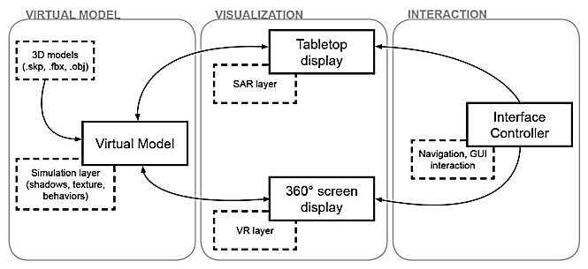

Fig:5 Application framework for CORAULIS [17]

An augmented reality learning system called SMART is described in a research article [10]. According to this research, SMART is a collaborative AR system designed specifically for 2nd grade students to learn about different transportation methods and animal species. The setup for this study included a number of rackets, including an AR tag, laptop, software, webcam, and projector. The study was conducted with 54 students from three different local primary school. At each school, participants were randomly divided into two groups: (1) a control group using traditional thematic teaching methods; (2) an experimental group using SMART systems as teaching tools. Interestingly, the SMART students in this study showed positive effects on motivation, learning experience, and collaboration [10].

Another AR application called CONSTRUCT3D stood out in research [6]. CONSTRUCT 3D can be described as a three-dimensional tool for creating geometric objects, based on a collaborative AR system called "StudioStube". StudioStube works in augmented reality to share virtual space among multiple users. It enables the combination of output devices such as personal HMD, virtual workbench, traditional monitors, and inputs from a variety of personal tracking devices to function as a single distributed system. The current state of CONSTURCT 3D offers a basic set of functions for the construction of primitives such as points, lines, planes, cubes, spheres, cylinders and cones. Construction functions include intersections, Boolean operations, normal lines and planes, symmetry operations, and taking measurements. The current state of Construct 3D provides a basic set of functions for primary constructions such as points, lines, planes, cubes, spheres, cylinders, and cones. Construction functions include intersections, Boolean operations, shared lines and planes, symmetric operations, and measurements [6].

REFERENCES

[1] Ardiny, Hadi, and Esmaeel Khanmirza. "The role of AR and VR technologies in education developments: opportunities and challenges." 2018 6th RSI International Conference on Robotics and Mechatronics (IcRoM). IEEE, 2018.

[2] Freina, Laura, and Michela Ott. "A literature review on immersive virtual reality in education: state of the art and perspectives." The international scientific conference elearning and software for education. Vol. 1. No. 133. 2015.

[3] Elmqaddem, Noureddine. "Augmented reality and virtual reality in education. Myth or reality?." International journal of emerging technologies in learning 14.3 (2019).

[4] Huang, Kuo-Ting, et al. "Augmented versus virtual reality in education: an exploratory study examining science knowledge retention when using augmented reality/virtual reality mobile applications." Cyberpsychology, Behavior, and Social Networking 22.2 (2019): 105-110.

[5] Mones, Barbara. "Before and after AR/VR: Empowering paradigm shifts in education." SIGGRAPH Asia 2017 Symposium on Education. 2017.

[6] Kaufmann, Hannes. "Collaborative augmented reality in education." Institute of Software Technology and Interactive Systems, Vienna University of Technology (2003).

[7] Horváth, Ildikó. "Evolution of teaching roles and tasks in VR/AR-based education." 2018 9th IEEE International Conference on CognitiveInfocommunications (CogInfoCom). IEEE, 2018.

[8] Al-Azawi, Rula, et al. "Exploring the potential of using augmented reality and virtual reality for STEM education." International Workshop on Learning Technology for Education in Cloud. Springer, Cham, 2019.

[9] Martín-Gutiérrez, Jorge, et al. "Virtual technologies trends in education." EURASIA Journal of Mathematics, Science and Technology Education 13.2 (2017): 469-486.

[10] Phon, Danakorn Nincarean Eh, Mohamad Bilal Ali, and Noor Dayana Abd Halim. "Collaborative augmented reality in education: A review." 2014 International Conference on Teaching and Learning in Computing and Engineering. IEEE, 2014.

[11] Milgram, Paul, et al. "Augmented reality: A class of displays on the reality-virtuality continuum." Telemanipulator and telepresence technologies. Vol. 2351. International Society for Optics and Photonics, 1995.

[12] Schnabel, Marc Aurel, et al. "From virtuality to reality and back." (2007).

[13] Paul, Sujni, Saif Hamad, and Sultan Khalid. "The Role of AR/VR in an IoT connected digital enterprise for smart education." 2019 Sixth HCT Information Technology Trends (ITT). IEEE, 2019.

[14] Mekacher, Leila. "Augmented reality (Ar) and virtual reality (Vr): the future of interactive vocational education and training for people with handicap." Pupil: Int. J. Technol. Enhanc. Learn.(IJTEL) 3.1 (2019).

[15] Wang, Minjuan, et al. "Augmented reality in education and training: pedagogical approaches and illustrative case studies." Journal of ambient intelligence and humanized computing 9.5 (2018): 1391-1402.

[16] Liu, Dejian, et al., eds. Virtual, augmented, and mixed realities in education. Singapore: Springer, 2017.

[17] Milovanovic, Julie, et al. "Virtual and augmented reality in architectural design and education." 17th International Conference, CAAD Futures 2017. 2017.

[18] Puggioni, Maria Paola, et al. "A content creation tool for AR/VR applications in education: The ScoolAR framework." International conference on augmented reality, virtual reality and computer graphics. Springer, Cham, 2020.

[19] Magomadov, V. S. "Examining the potential of VR and AR technologies for education." Journal of Physics: Conference Series. Vol. 1691. No. 1. IOP Publishing, 2020.